Assignment-4

1) Write a select command that produces the order number, amount, and date for all

rows in the Orders table.

Solution- select Onum,Amt,Odate from ORDERS;

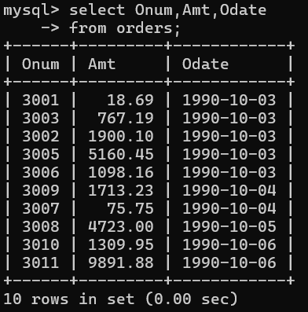

2) Write a query that produces all rows from the Customers table for which the

salesperson’s number is 1001.

Solution- select \* from SALESPEOPLE where Snum = 1001;

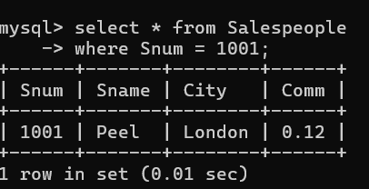

3) Write a query that displays the Salespeople table with the columns in the

following order: city, sname, snum, comm.

Solution- select City, Sname, Snum, Comm from SALESPEOPLE;

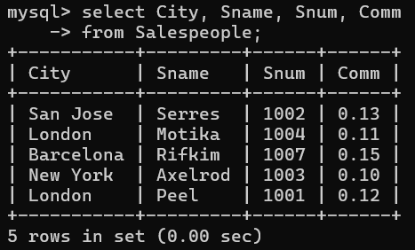

4) Write a select command that produces the rating followed by the name of each

customer in San Jose.

Solution- select Rating, Cname from CUSTOMERS where City = 'San Jose';

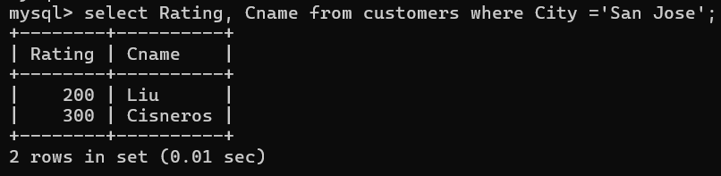

5) Write a query that will produce the snum values of all salespeople (suppress the

duplicates) with orders in the Orders table

Solution- select DISTINCT Snum from ORDERS;

